**Project Development Phase**

**Sprint – 4**

|  |  |
| --- | --- |
| Date | 15 November 2022 |
| Team ID | PNT2022TMID45233 |
| Project Name | AI Based Discourse for Banking Industry |
| Maximum Marks | 8 Marks |

DEPLOYMENT PHASE-II

BUILD HTML:

* A Simple Bank Home page was designed using html (Ex chatbot.html)
* It is front end part of bank website

RUN Application:

* Open command prompt in project folder
* Run this command python -m flask run
* The project is running on the localhost:5000 port OUTPUT:

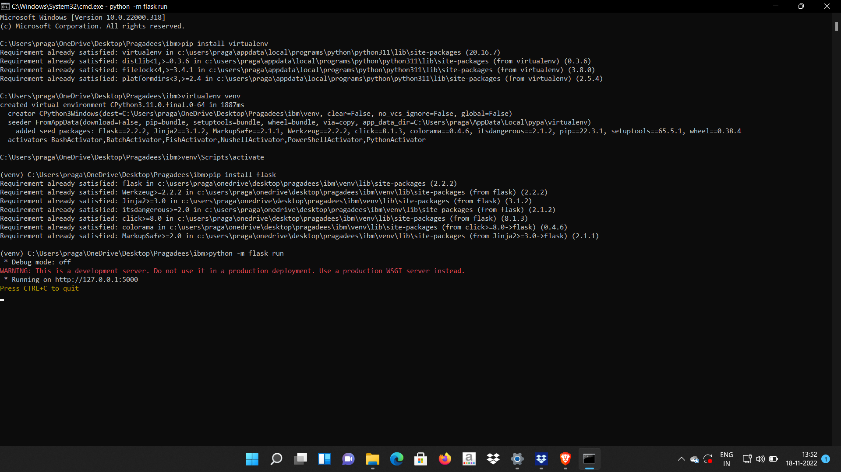

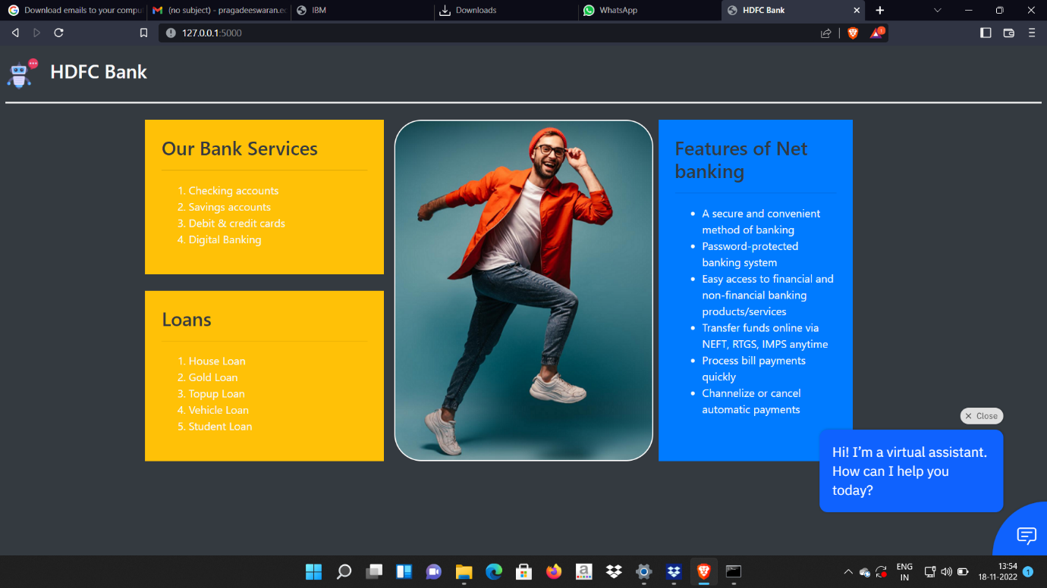

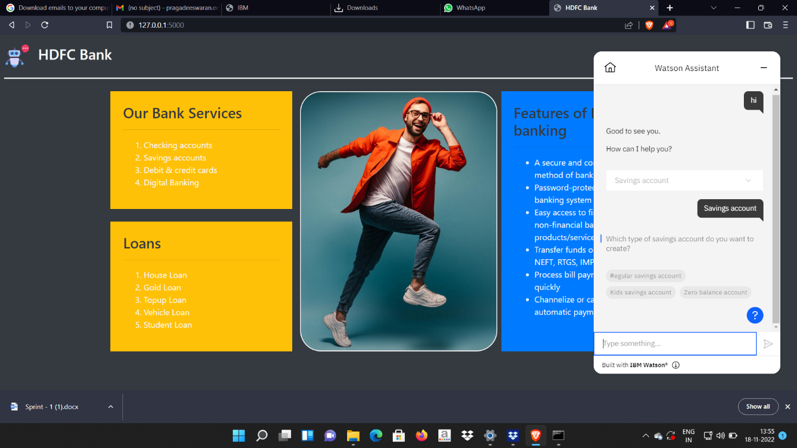

HTML & CSS File

<!DOCTYPE html>

<html>

<head>

<meta charset="utf-8">

<meta name="viewport" content="width=device-width, initial-scale=1">

<title>HDFC Bank</title>

<link rel="stylesheet" href="https://cdn.jsdelivr.net/npm/bootstrap@4.0.0/dist/css/bootstrap.min.css" integrity="sha384-Gn5384xqQ1aoWXA+058RXPxPg6fy4IWvTNh0E263XmFcJlSAwiGgFAW/dAiS6JXm" crossorigin="anonymous">

</head>

<style type="text/css">

.col2{

background-image:url({{ url_for ('static', filename = 'back.png') }});

background-position: center;

background-repeat: no-repeat;

}

</style>

<body class="bg-dark">

<!--Navbar-->

<div class="bg-dark text-light p-2">

<h3 class="mt-2">

<img src="{{url_for('static', filename='robot.png')}}" align="middle" width="50px" height="50px" />&nbsp;&nbsp;HDFC Bank</h3>

<hr style="color: white;background-color: white;height: 2px;" />

</div>

<div class="container">

<div class="row">

<div class="col-md-4">

<div class="bg-warning text-light p-4 ">

<h3 class="text-dark">Our Bank Services</h3>

<hr/>

<ol>

<li>Checking accounts</li>

<li>Savings accounts</li>

<li>Debit & credit cards</li>

<li>Digital Banking</li>

</ol>

</div><br/>

<div class="bg-warning text-light p-4">

<h3 class="text-dark">Loans</h3>

<hr/>

<ol>

<li>House Loan</li>

<li>Gold Loan</li>

<li>Topup Loan</li>

<li>Vehicle Loan</li>

<li>Student Loan</li>

</ol>

</div>

</div>

<div class="col-md-4 col2" style="border:2px solid white;border-radius: 40px;">

</div>

<div class="col-md-3 bg-primary text-light ml-2 p-4">

<h3 class="text-dark">Features of Net banking</h3>

<hr/>

<ul>

<li>A secure and convenient method of banking</li>

<li>Password-protected banking system</li>

<li>Easy access to financial and non-financial banking products/services</li>

<li>Transfer funds online via NEFT, RTGS, IMPS anytime</li>

<li>Process bill payments quickly</li>

<li>Channelize or cancel automatic payments</li>

</ul>

</div>

</div>

</div>

<script>

window.watsonAssistantChatOptions = {

integrationID: "194645db-c1b0-4c82-8a00-416bde4eaf02", // The ID of this integration.

region: "au-syd", // The region your integration is hosted in.

serviceInstanceID: "58ea46b1-9b1e-45dc-bdec-07b56e87e647", // The ID of your service instance.

onLoad: function(instance) { instance.render(); }

};

setTimeout(function(){

const t=document.createElement('script');

t.src="https://web-chat.global.assistant.watson.appdomain.cloud/versions/" + (window.watsonAssistantChatOptions.clientVersion || 'latest') + "/WatsonAssistantChatEntry.js";

document.head.appendChild(t);

});

</script>

<body>

</html>